**Project YT**

**Objectives** are to evaluate capabilities of developers concerning

a)       Show your coding skills

b)      Show  your capabilities to learn new technologies

c)       Show your capabilities to support a working product with required documentation to understand and execute the solution

**Scope:**

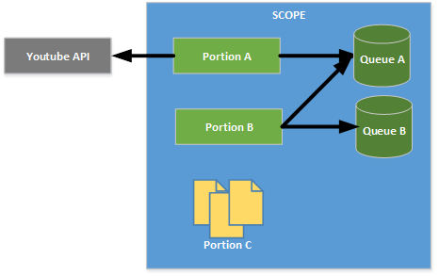

•         Part A - build a solution in Java that will

o   Connect to youtube using the youtube APIs (<https://developers.google.com/youtube/>) and retrieve all video metadata containing the word “telecom” in the title

o   For each video identified, publish an XML message in Queue A, containing at least the following information:

▪  URL

▪  Video title

•         Part B- build a solution in Java that will

o   Consume the XML messages from JMS Queue A (output of Part A)

o   Modify the video Title in each XML message, replacing the word “telecom” with the word “telco”

o   Store the modified XML message in JMS queue B

•         Part C - Provide a document describing

o   Which design patterns have you used in the implementation

o   Schema describing the messages produced by the solution

o   How to compile the source code produced

o   How to execute your programs to produce the results previously described

o   Looking back at the implementation, what would you consider doing differently